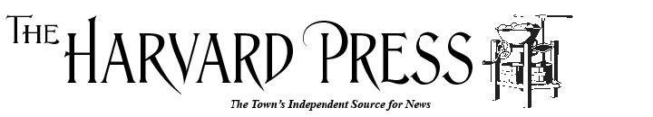

Application for Summer 2025 Internship
Thank you for your interest in a Harvard Press summer internship. Please complete this form and return it to John Osborn, Editor, at editor@harvardpress.net. If you need more space, you’re welcome to continue your answers on additional pages at the end of this application. Include three published stories that you feel best represent your work. If you have a resume, please send that along as well. We look forward to hearing from you. Once we have received your application, we will set a date for a follow-up Zoom interview.

Applicant Information
Full Name: |  |  |  | Date:
 | Last | First | M.I.

Address:
 | Street Address |  | Apartment/Unit #
 | City | State | ZIP Code

Phone: |  | Email

Date you can start (dd/mm/yyyy): | __________________ |  | Date you must return to school (dd/mm/yyyy): | _____________________
Some stories can be reported remotely, but others may require your presence in person. Do you have the means to travel to Harvard? How?

Education and Experience
High School: |  | Address:

From: _________ |  | To: ________ |  | Did you graduate? | YES |  | NO |  | Diploma: | _____________________
College: | _______________________ |  |  | City and state: |  | ____________________________________
When will you graduate? |  |  | ___________________ |  | Degree: |  |  | ________________________________
What is your major? Any minors or certificates of study)?
What journalism or writing courses have you completed. Which was your favorite?
Have you written for your college newspaper? If so, describe your role as reporter or editor, or both. If you had a beat, what was it?

Personal Goals
What new reporting, writing, or editing skills do you hope to develop through your internship with the Harvard Press?

If you could choose your beat or an issue on which to focus for your internship, what would it be?
What attracts you to journalism?
Why did you choose to apply to the Harvard Press for a summer internship?

References
Please list one reference who is familiar with your writing or work as a student, reporter or editor.
Full Name:
Organization:
Address:

Disclaimer and Signature
I certify that my answers are true and complete to the best of my knowledge.
Signature: |  | Date:

